Name

Mathematics Stage 5 Core
Significant Figures and Scientific Notation

Book 1 |  | Version: 261005  Feedback:  https://MrDingMaths.com
Contents
Syllabus Content 2
Learning Intention 3

Syllabus Content
MA5-MAG-C-01 solves measurement problems by using scientific notation to represent numbers and rounding to a given number of significant figures
Identify and describe very small and very large measurements
- Identify and describe the meaning of common prefixes, such as milli, centi and kilo
- Establish the meaning of prefixes for very small or very large measurement units
Estimate and round numbers to a specified degree of accuracy
- Apply the language of estimation appropriately, including the terms rounding, approximate and level of accuracy
- Round numbers to a specified number of significant figures
- Examine the effect that truncating or rounding during calculations has on the accuracy of the results
Express numbers in scientific notation
- Recognise the need for notation to express very large or very small numbers
- Represent numbers using scientific notation in practical contexts
- Order numbers expressed in scientific notation
- Represent numbers expressed in scientific notation as a decimal
- Estimate the value of calculations involving scientific notation by applying knowledge of index laws
- Solve problems with calculations involving scientific notation using digital tools

The Metric System

- Metric Prefixes
- The metric system of measurement bases everything on powers of 10.
- The prefix of a unit of measurement tells you how large or small it is.

Prefix | Meaning | Index notation | Number | Fraction
Giga G | Billion | $${10}^{9}$$ | $$1 000 000 000$$ | -
Mega M | Million | $${10}^{6}$$ | $1 000 000$ | -
kilo k | Thousand | $${10}^{3}$$ | $$1000$$ | -
(no prefix) | One | 1 | $$1$$ | $$1$$
centi c | Hundredth | $${10}^{-2}$$ | $$0.01$$ | $$\frac{1}{100}$$
milli m | Thousandth | $${10}^{-3}$$ | $$0.001$$ | $$\frac{1}{1000}$$
micro $μ$ | Millionth | $${10}^{-6}$$ | $$0.000 001$$ | $$\frac{1}{1 000 000}$$
nano $n$ | Billionth | ${10}^{-9}$ | $$0.000 000 001$$ | $$\frac{1}{1 000 000 000}$$

- Unusual units, e.g. centilitres, are used in other countries and laboratory, pharmaceutical, or medical fields.

- SI Units
- SI units are internationally agreed upon units of measurement.
- The prefix of the SI unit tells you how large or small the unit of measurement is.

Quantity | SI unit
Length | Metre (m)
Capacity | Litre (L)
Mass | Gram (g)
Time | Second (s)
Energy | Joule (J)

- Note: for time, we use metric units only when using smaller units of measurement;
millisecond is widely used; kilosecond is only used in specific scientific and computing fields.

Foundation
- Complete the table.
Prefix | Meaning | Index notation
Giga G | Billion | $${10}^{9}$$
M  Mega | Million | $${10}^{6}$$
kilo k | thousand | $${10}^{3}$$
(no prefix) | One | 1
centi C | hundredth | $${10}^{-2}$$
milli  m | thousandth | $${10}^{-3}$$
$μ$  micro | millionth | $${10}^{-6}$$
nano n | Billionth | $${10}^{-9}$$

- Complete the table.
Prefix | Meaning | Index notation
kilo k | Thousand | $${10}^{3}$$
(no prefix) | One | 1 or ${10}^{0}$
nano n | Billionth | $${10}^{-9}$$
G  Giga | Billion | $${10}^{9}$$
milli m | Thousandth | $${10}^{-3}$$
Micro  $μ$ | Millionth | $${10}^{-6}$$
centi c | Hundredth | $${10}^{-2}$$
Mega M | Million | $${10}^{6}$$

Metric Conversions

- Metric Conversions
If converting to a smaller unit multiply
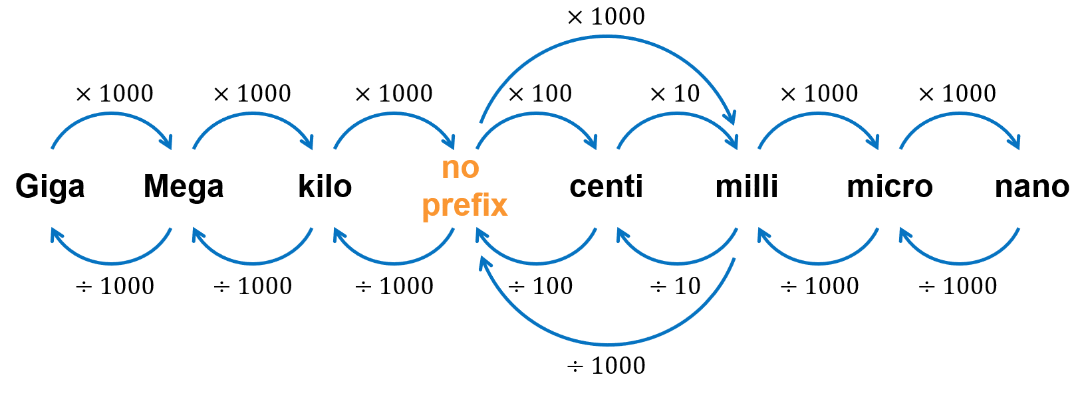
If converting to a larger unit, divide

- Note: a tonne (t) is 1000 kg or 1 Mg

- Example Convert metric units
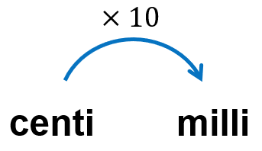  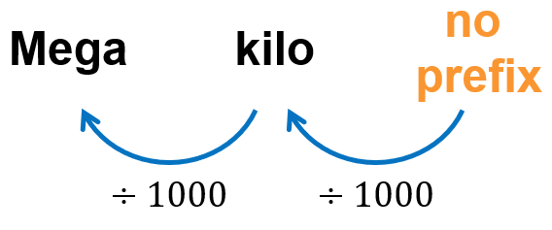  Convert 35 cm to mm  $35 cm×10$  $$=350 mm$$ | Convert 520 000 L to ML  $520 000 L÷1000÷1000$  $$=0.52 ML$$

- Guided Practice
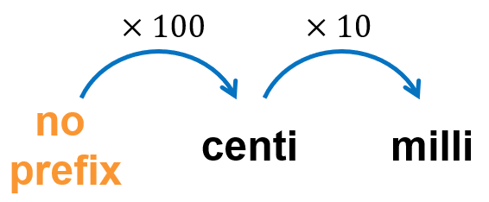  - 25 m to mm  25 000 mm | 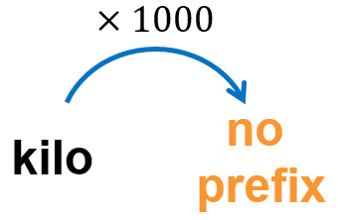  - 1500 kg to g  1 500 000 g
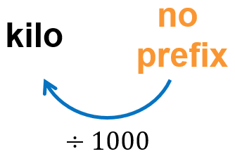  - 6700 g to kg  6.7 kg | - 11.55 L to mL  11 550 mL
- 8 500 000 mL to kL  8.5 kL | - 80 mL to L  0.08 L

Foundation
- Convert the following.
- 2 L$=$ ……… mL  2000 | - 12 kL $=$ ……… L  12 000 | - 9 kL $=$ ……… mL  9 000 000
- 7800 kL $=$ ……… L  7 800 000 | - 50 L $=$ ……… mL  50 000 | - 300 kL $=$ ……… mL  300 000 000
- 6100 L $=$ ……… kL  6.1 | - 400 mL $=$ ……… L  0.4 | - 210 000 mL $=$ ……… kL  0.21
- 3 t $=$ ……… kg  3000 | - 45 kg $=$ ……… g  45 000 | - 76 t $=$ ……… kg  76 000
- 8100 kg $=$ ……… g  8 100 000 | - 4 t $=$ ……… g  4 000 000 | - 0.52 t $=$ ……… kg  520
- 6800 g $=$ ……… kg  6.8 | - 300 kg $=$ ……… t  0.3 | - 2300 g $=$ ……… kg  2.3

- Fill in the table.
 | km | m | cm | mm
 | 1 | 1000 | 100 000 | 1000 000
 | 0.001 | 1 | 100 | 1000
 | 0.000 01 | 0.01 | 1 | 10
 | 0.000 001 | 0.001 | 0.1 | 1
 | 0.000 01 | 0.01 | 1 | 10
 | 0.000 17 | 0.17 | 17 | 170
 | 0.001 7 | 1.7 | 170 | 1700
 | 1.07 | 1070 | 107 000 | 1 070 000
 | 0.07 | 70 | 7000 | 70 000
 | 0.000 07 | 0.07 | 7 | 70
 | 0.000 000 7 | 0.000 7 | 0.07 | 0.7
 | 0.000 25 | $$\frac{1}{4}$$ | 25 | 250

Development
- There are 20 litres of a chemical stored in a container.
  - What amount of chemical remains if 750 mL is removed from the container?
Answer in litres.
19.25 L
  - How many containers are required to hold a kilolitre of the chemical?

50 containers
- The length of the Murray River is 2575 km. The length of the Hawkesbury River is 80 000 m. What is the difference in their lengths? Answer in metres.

2 495 000 m
- Christopher bought 3 kg of sultanas. What mass of sultanas remains if he ate 800 grams? Answer in kilograms.

2.2 kg
- A truck is loaded with 3000 bricks, each of mass 4 kg. Find the total mass (in t) of the bricks.

12 t
- The mass of a box of cereal is 375 g. What is the total mass (in kg) of 15 boxes of cereal?

5.625 kg
- Find the total mass (in g) of five items of mass 250 mg,1100 mg, 0.7 g, 5.95 g, and 15.4 g.

23.4 g
- An empty plastic box has mass 750 g. It is packed with 8 bottles of drink, each of mass 1.25 kg. Calculate the total mass (in g) of the packed box.

10 750 g
- A cyclist travels to and from work over a 1200-metre long bridge. Calculate the distance travelled in a week if the cyclist works for 5 days. Answer in kilometres.

12 km

Mastery
- Convert the following.
- 7.2 Gg to t  7200 t | - 2.9 cg to ng  29 000 000 ng | - 9 kL to mL  9 000 000 mL
- 4.3 cm to $μ$m  43 000 $μ$m | - 5.3 ms to ns  5 300 000 ns | - 9 kg to mg  9 000 000 mL

- Warragamba dam holds approximately 2 580 000 ML of water at full capacity.
How many gigalitres is this?

2580 GL
- A computer can access its memory in 24 ns. Convert this to microseconds.
24 000 $μ$s
- Tera- (T) is the metric prefix for trillion (${10}^{12}=1 000 000 000 000)$.
The distance from Mars to the Sun is 0.228 Tm. Convert this distance to kilometres.

228 000 000 km
- The mass of a hydrogen atom is $1.67×{10}^{-24}$ g.
What is the mass in nanograms of 1 million hydrogen atoms?

$1.67×{10}^{-9}$ ng
- The total solar energy hitting Australia in one minute is estimated (by ChatGPT) to be $7.22×{10}^{19}$ Joules. Australia’s annual energy consumption is 6500 Petajoules (${10}^{18})$.
Assuming we can harness all the solar energy, for how long would we need to collect solar energy to power the whole country for a year?

$$6500×{10}^{18}÷(7.22×{10}^{19})$$
Around 90 minutes.

Significant Figures

- Significant Figures
- Significant figures are meaningful digits in a number.
- It’s impossible to cut a piece of timber to a length of 1.333 333… m.
- The digits after a certain figure, or digit, are meaningless.
- Rules for significant figures:
  - The first significant figure is the first non-zero digit (reading from left to right).
  - All non-zero digits are significant.
  - Zeros between non-zero digits are significant.
  - Zeros on the end of a decimal are significant.
  - Zeros on the end of a whole number may be significant.
Treat them as significant until we learn scientific notation.
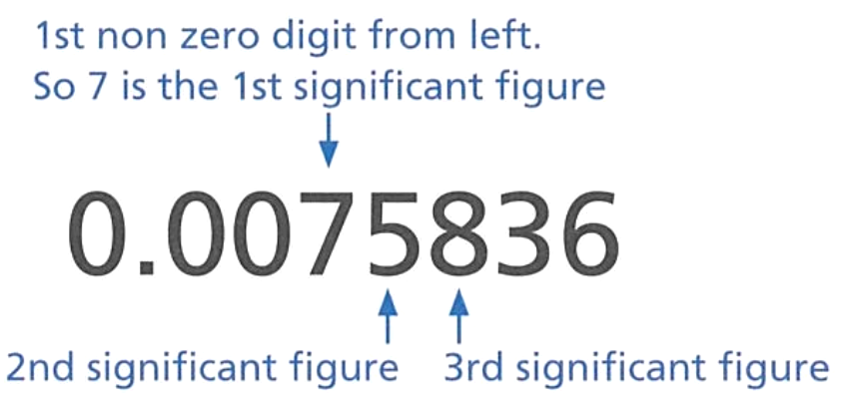

- Identify number of significant figures
- 456 | - 0.04 | - 1.45006 | - 4.00067
- 450 | - 0.004 | - 450067 | - 0.00067
- 406 | - 0.00456 | - 45067 | - 0.0067
- 400 | - 0.456 | - 4506.7 | - 6.0007
- 40 | - 0.406 | - 450.67 | - 0.6007
- 4 | - 0.450 | - 45.067 | - 0.0607
- 0.4 | - 0.4500 | - 45.0067 | - 1.06070
- 0.40 | - 0.45006 | - 4.50067 | - 1.060700

- Round to a Significant Figure
- To round to 𝑛 significant figures:
- Identify the $n$th significant figure.
- Determine the place value of this digit.
- Round to this place value.

- Example Round numbers to a specific number of significant figures
Round 56718 to one significant figure.  1. The first significant figure is digit 5,  2. representing ten thousand.  3. We round to the nearest ten thousand.  $$56718≈60000 (1 s.f.)$$ | Round 0.0068463 to two significant figures.  1. The 2nd significant figure is digit 8,  2. the 4th decimal place.  3. We round to the 4th decimal place.  $$0.0068463≈0.0068 (2 s.f.)$$

- Guided Practice
Round these numbers to the required significant figures
- 428.3 (1 s.f.)  1st significant figure: ………  Round to nearest ……………  $428.3≈$ …………… (1 s.f.)  400 | - 629.51 (3 s.f.)  3rd significant figure: …………  Round to nearest ……………  $629.51≈$ …………… (3 s.f.)  630
- 6103 (2 s.f.)  6100 | - 0.005072 (2 s.f.)  0.0031
- 0.03926 (3 s.f.)  0.0393 | - 0.56201 (2 s.f.)  0.56

- Key Ideas
- For numbers based on measurements. Not all digits have meaning, due to the limits of ……………………
- Only digits with meaning are written. These digits are called ……………….. figures.

Foundation
- Decide how many significant figures are in these quantities.
- 1.234  4 | - 0.001  1
- 1.2  2 | - 0.012  2
- 1002  4 | - 1.023  4
- 3.07  3 | - 0.200  3

- Complete the following to round 28.470 58 to the given level of accuracy.
- 1 s.f.  1st significant figure: 2  Round to nearest ten  $28.470 58≈$ ………… (1 s.f.)  30 | - 2 s.f.  2nd significant figure: ………  Round to nearest ……………  $28.470 58≈$ ………… (2 s.f.)  28 | - 3 s.f.  3rd significant figure: ………  Round to nearest ……………  $28.470 58≈$ ………… (3 s.f.)  28.5

- Complete the following to round 0.037 09 to the given level of accuracy.
- 1 s.f.  1st significant figure: ………  Round to nearest ……………  $0.037 09≈$ ………… (1 s.f.)  0.04 | - 2 s.f.  2nd significant figure: ………  Round to nearest ……………  $0.037 09≈$ ………… (2 s.f.)  0.037 | - 3 s.f.  3rd significant figure: ………  Round to nearest ……………  $0.037 09≈$ ………… (3 s.f.)  0.0371


- Anna rounds 7382 to 1 significant figure. She says:
The answer is 7000. It was the same as rounding to the nearest 1000.

Explain why rounding to 1 significant figure is not always the same as rounding to the nearest 1000. Give an example.
First significant figure is not always thousands.
For example: 81, the first significant figure is 8, which is tens.
Round each of these numbers to 1 significant figure.
50 000 | 5000 | 500
50 | 5 | 0.5

Development
- Round the following:
- 4 170 162 | - 0.003 661 2 | - 24.8706
  Sig Figs | Rounded
  1 | 4 000 000
  2 | 4 200 000
  3 | 4 170 000
  4 | 4 170 000
  Sig Figs | Rounded
  1 | 0.004
  2 | 0.003 7
  3 | 0.003 66
  4 | 0.003 661
  Sig Figs | Rounded
  1 | 20
  2 | 25
  3 | 24.9
  4 | 24.87

- Write these numbers correct to the number of significant figures indicated.
- 1 561 231 (2 s.f.)  1 600 000 | - 3677 720 (4 s.f.)  3 678 000 | - 789 001 (5 s.f.)  789 000
- 3 300 000 (1 s.f.)  3 000 000 | - 777 777 (3 s.f.)  778 000 | - 3194 729 (5 s.f.)  3 194 700
- 0.0035 (1 s.f.)  0.004 | - 0.191 785 (4 s.f.)  0.1918 | - 0.001 592 (3 s.f.)  0.001 59
- 0.111 222 (5 s.f.)  0.111 22 | - 0.000 0271 (1 s.f.)  0.000 03 | - 0.019 832 (5 s.f.)  0.019 832

- Most questions will ask you to round to either 2 decimal places or 3 significant figures.
For each of these numbers, round to 2 decimal places and to 3 significant figures.
 | 2 d.p. | 3 s.f.
- 17.962 | 17.96 | 18.0
- 1.4638 | 1.46 | 1.46
- 47.859 | 47.86 | 47.9
- 804.5272 | 804.53 | 805
- 500.5749 | 500.57 | 501
- 821.2749 | 821.27 | 821
- 5810.2539 | 5810.25 | 5810
- 0.02389 | 0.02 | 0.0239
- 0.01537 | 0.02 | 0.0154

Mastery
- Round to 2 sf.
- $32$  32 | - $36.8$  37 | - $0.000 003 68$  0.000 003 7 | - $4.900 093 68$  4.9
- $320$  320 | - $3.68$  3.7 | - $0.000 013 68$  0.000 014 | - $490 009 368$  490 000 000
- $328$  330 | - $0.368$  0.37 | - $4.000 013 68$  4.0 | - $4 900 093 680$  4 900 000 000
- $368$  370 | - $0.0368$  0.037 | - $4.000 093 68$  4.0 | - $4 090 009 368$  4 100 000 000

- Work out each of these on your calculator. Round each answer to 2 significant figures.
- $1.89× 319.175$  600 | - $\sqrt{3}×\sqrt{2}$  2.4 | - $195×4.3$  840 | - $\frac{2355×978}{1.95}$  1 200 000

- The number 5$□$3 is rounded to 1 significant figure. The answer is 600.
What could the original number have been?

Any digit 5 to 9
- A number rounded to 1 significant figure is 100 000.
The same number rounded to 2 significant figures is 100 000.
The same number rounded to 3 and to 4 significant figures is also 100 000.
What could the number be?

99999 (many possible answers)
- By rounding each number to 1 significant figure, estimate the answers to these calculations.
- $58×72$  4200 | - $7.3×9.6$  70 | - ${88}^{2}$  8100 | - $512÷4.78$  100

- The speed of light in a vacuum is 299 792 458 m/s. Round this number to:
- 1 s.f.  300 000 000 | - 2 s.f.  300 000 000 | - 3 s.f.  300 000 000
  - What do you notice?

They’re the same

- 2016 HSC Standard 2 Band 4
What is 208.345 correct to two significant figures?
- 208
- 210
- 208.34
- 208.35
B
- 2022 HSC Standard 1
The area (A) of a circle is given by the formula $A=πr^{2}$ , where $r$ is the radius.
What is the value of $A$, correct to three significant figures, if $r=3.55$?
- 39.5
- 39.6
- 39.591
- 39.592
B
- 2014 HSC Advanced Band 3
What is the value of $\frac{π^{2}}{6}$ correct to 3 significant figures?
- 1.64
- 1.65
- 1.644
- 1.645
A

Scientific Notation (Standard Form)

- Review
- Complete the following:
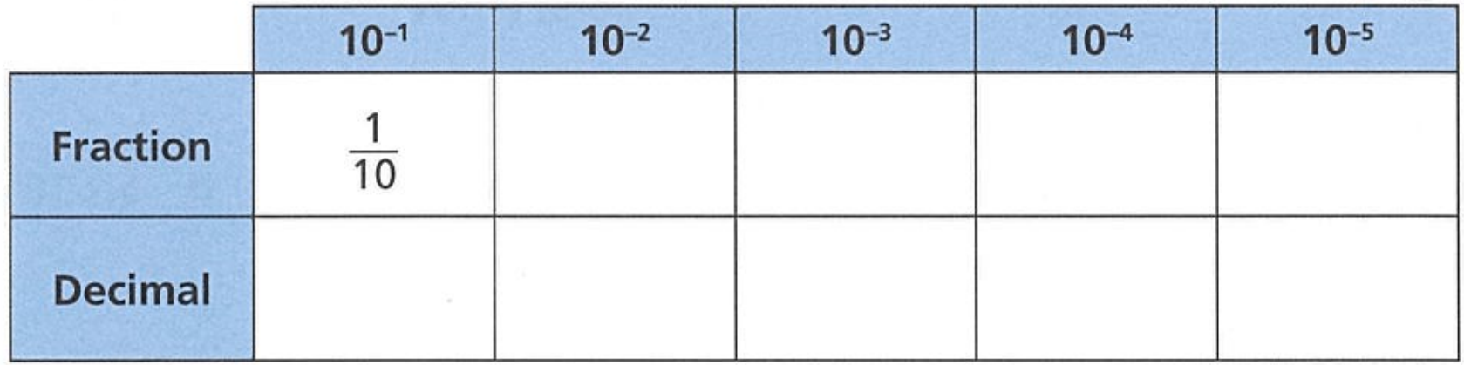

- Complete the table. You can use your calculator to help you.
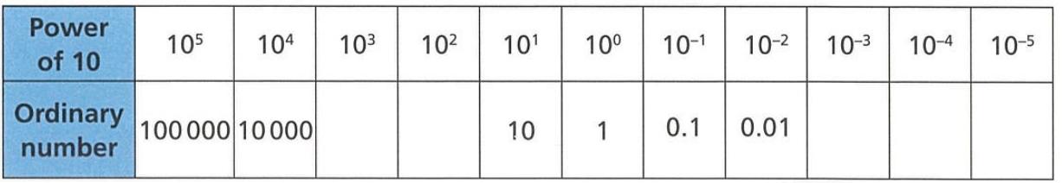

  - Which powers of 10 are large?
  - Which powers of 10 are small?
  - Which powers of 10 are positive?
  - Which powers of 10 are negative?

  - Write one million as a power of 10.
  - Write one millionth as a power of 10.
  - What is the same about your answers? What is different?

- Scientific Notation (Standard Form)
- Scientific notation, or standard form, shows very large or very small numbers.
- Scientific notation expresses numbers as a multiple of a power of 10.
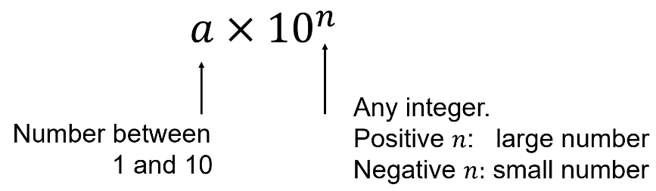

- Identify the largest place column to have value (i.e. the first significant figure),
then treat that as the new counting unit.
  - 6 500 000 “6.5 million” $6.5×{10}^{6}$
  - 300 000 “3 hundred thousands” $3×{10}^{5}$
  - 0.004 35 “4.35 thousandths” $4.35×{10}^{-3}$

- Identify numbers written in scientific notation
✖  $$30×{10}^{5}$$ | ✔  $$3×{10}^{5}$$ | ✔  $$3.85×{10}^{-12}$$ | ✖  $$0.85×{10}^{-12}$$
Determine whether these numbers are written in scientific notation
- $3×{10}^{5}$ | - $3×{10}^{6}$ | - $3×{10}^{67}$ | - $3×{10}^{6.7}$
- $3×{10}^{0.67}$ | - $3×{10}^{7}$ | - $3×{10}^{-7}$ | - $3×{10}^{-0.7}$
- $3×{100}^{7}$ | - $30×10$ | - $30×{10}^{7}$ | - $30×{10}^{-7}$
- $0.3×{10}^{7}$ | - $3.3×{10}^{7}$ | - $3.0×{10}^{7}$ | - $30000$

- Key Ideas
- Scientific notation and …………………… form refer to the same thing:
$a×{10}^{n}$, where $a$ is a number between ………… and …………, and $n$ is an ………………

Foundation
- Decide whether these numbers have been written in scientific notation or not.
- $5.9×{10}^{6}$  yes | - $34×{10}^{8}$  no | - $8.97×10 000$  no | - $5.03×{10}^{-9}$  yes
- $28000$  no | - $7×{10}^{-15}$  yes | - $0.85×{10}^{4}$  no | - $2.006×{10}^{60}$  yes

- Complete the table.
Scientific notation | Expanded Form | Basic Numeral
$5×{10}^{3}$ | $5×1000$ | $5 000$
$3×{10}^{4}$ | $$3×10 000$$ | $$30 000$$
$2×{10}^{5}$ | $$2×100 000$$ | $$300 000$$
$$7×{10}^{4}$$ | $$7×10 000$$ | $70 000$
$$4×{10}^{5}$$ | $$4×100 000$$ | $400 000$
$$2×{10}^{5}$$ | $$2×100 000$$ | $200 000$

- Complete the table.
Scientific notation | Fraction | Basic Numeral
$2×{10}^{-4}$ | $$\frac{2}{{10}^{4}}=\frac{2}{10 000}$$ | $0.0002$
$3×{10}^{-2}$ | $$\frac{3}{100}$$ | 0.03
$5×{10}^{-3}$ | $$\frac{5}{1000}$$ | 0.005
$$8×{10}^{-2}$$ | $$\frac{8}{100}$$ | $0.08$
$$6×{10}^{-4}$$ | $$\frac{6}{10 000}$$ | $0.0006$
$$4×{10}^{-5}$$ | $$\frac{4}{100 000}$$ | $0.00004$

Converting to Scientific Notation

- Converting to Scientific Notation
- Move the decimal point after the first non-zero digit.
- Count digits between the new and old decimal points. This is the power of 10.
- Write the power of 10:
  - Positive for large numbers,
  - Negative for small numbers.
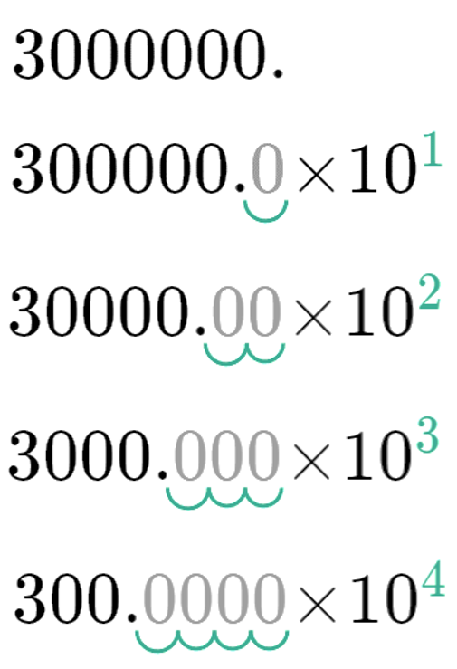
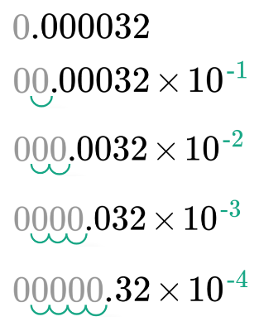

- Example Represent numbers using scientific notation
Convert to scientific notation
$246000$  $2.46000$  $$=2.46×{10}^{5}$$ | 0.00071  $0 0007.1$  $$=7.1×{10}^{-4}$$

- Guided Practice
Convert these numbers to scientific notation
- 50 000  $$5×{10}^{4}$$ | - 452 000  $$4.52×{10}^{5}$$ | - 5300  $$5.3×{10}^{3}$$
- 0.004  $$4×{10}^{-3}$$ | - 0.000 57  $$5.7×{10}^{-4}$$ | - 0.000 0132  $$1.32×{10}^{-5}$$

Foundation
- Write these numbers in scientific notation.
$$2.6×{10}^{4}$$ | $$6.7×{10}^{2}$$ | 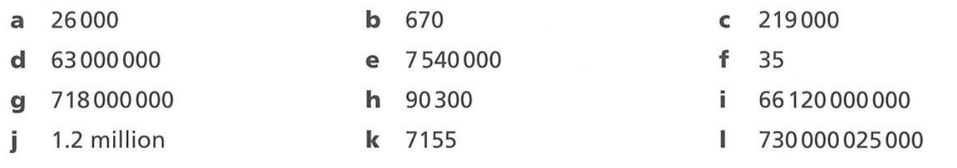  $$2.19×{10}^{5}$$
$$6.3×{10}^{7}$$ | $$7.54×{10}^{6}$$ | $$3.5×{10}^{1}$$
$$7.18×{10}^{8}$$ | $$9.03×{10}^{4}$$ | $$6.612×{10}^{10}$$
$$1.2×{10}^{6}$$ | $$7.155×{10}^{3}$$ | $$7.300 000 25×{10}^{11}$$

- Write each of these numbers in scientific notation.
- 0.12  $$1.2×{10}^{-1}$$ | - 0.012  $$1.2×{10}^{-2}$$ | - 0.0012  $$1.2×{10}^{-3}$$ | - 0.000 12  $$1.2×{10}^{-4}$$
- 0.000 03  $$3×{10}^{-5}$$ | - 0.000 032  $$3.2×{10}^{-5}$$ | - 0.000 031 7  $$3.17×{10}^{-5}$$

- Write the following numbers in scientific notation.
- 7600  $$7.6×{10}^{3}$$ | - 1 700 000 000  $$1.7×{10}^{9}$$ | - 0.000 56  $$5.6×{10}^{-4}$$
- 0.000 067 8  $$6.78×{10}^{-5}$$ | - 35 000  $$3.5×{10}^{4}$$ | - 0.26  $$2.6×{10}^{-1}$$
- 590 000  $$5.9×{10}^{5}$$ | - 6 800 000  $$6.8×{10}^{6}$$ | - 0.000 000 812  $$8.12×{10}^{-7}$$
- 0.004 3  $$4.3×{10}^{-3}$$ | - 310 000 000  $$3.1×{10}^{8}$$ | - 0.092  $$9.2×{10}^{-2}$$

- Express the following numbers in scientific notation.
  - The number of hairs on a person’s head is approximately 129 000. ………………………
$1.29×{10}^{5}$ hairs
  - The distance from Earth to the Sun is 152 000 000 km. ………………………
$1.52×{10}^{8}$ km
  - The diameter of a hydrogen atom is 0.000 000 002 54 cm. ………………………
$2.54×{10}^{-9}$ cm
  - The size of the influenza virus is 0.000 000 26 m. ………………………
$2.6×{10}^{-7}$ m

Converting to Decimal Form

- Converting to Decimal Form
- For $a×{10}^{n}$
- Move the decimal left or right depending on the value of $n$.
  - If $n$ is positive, move the decimal $n$ places to the right.
  - If $n$ is negative, move the decimal $n$ places to the left.
- Remember: big numbers have positive power, small numbers have negative power.

- Example Represent numbers as decimal form
Convert to decimal form.
$6.48×{10}^{5}$  $=$ $6 48000.$  $$=648 000$$ | $3.51×{10}^{-6}$  $=$ $0.000003 51$  $$=0.000 003 51$$

- Guided Practice
Convert these numbers to decimal form.
- $3×{10}^{4}$  30 000 | - $5×{10}^{-2}$  0.05 | - $3.9×{10}^{6}$  3 900 000
- $8.737×{10}^{2}$  873.7 | - $3.51×{10}^{-6}$  0.000 003 51 | - $2.71×{10}^{-5}$  0.000 027 1

Foundation
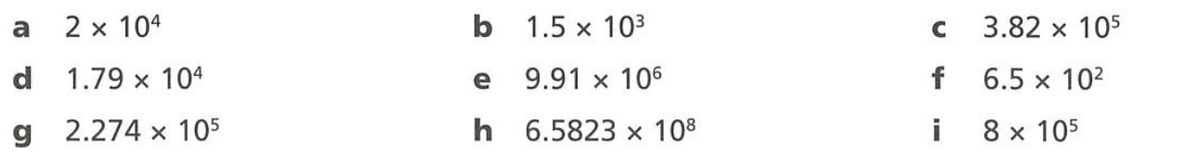
- Write these numbers in decimal form.
20 000 | 1500 | 382 000
17 900 | 9 910 000 | 650
227 400 | 658 230 000 | 800 000

- Write these numbers in decimal form.
0.0024 | 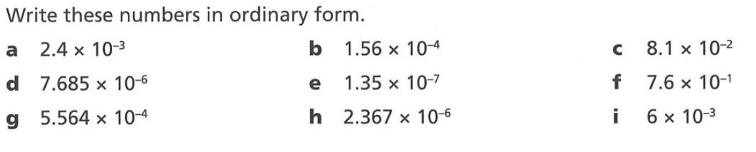  0.000 156 | 0.081
0.000 007 685 | 0.000 000 135 | 0.76
0.000 556 4 | 0.000 002 367 | 0.006

- Match the cards that are equal in value.
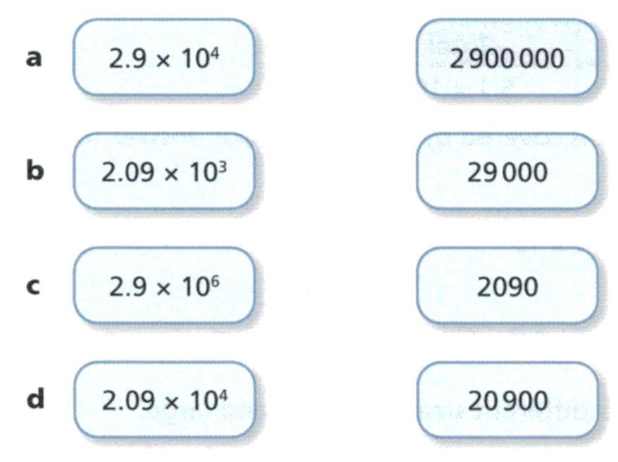

A | B | C | D

a – B, b – C, c – A, d – D
- Write the following numbers in decimal form.
- $1.12×{10}^{5}$  112 000 | - $5.34×{10}^{8}$  534 000 000 | - $5.81×{10}^{-3}$  0.00581
- $1.63×{10}^{-7}$  0.000 000 163 | - $2.4×{10}^{2}$  240 | - $3.5×{10}^{-4}$  0.00035
- $7.9×{10}^{-6}$  0.000 007 9 | - $5.2×{10}^{3}$  5200 | - $8.678×{10}^{7}$  86 780 000

- Jackson says: “$2.3×{10}^{4} = 230 000$”
Explain why he is incorrect and write $2.3×{10}^{4}$ in decimal form.
$$2.3×{10}^{4}=2.3×10 000=23 000$$

Mixed Practice

Foundation
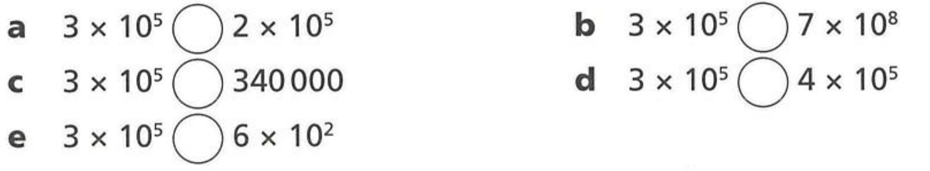
- Write >, <, or = to compare each pair of numbers.
> <
< <
> ..

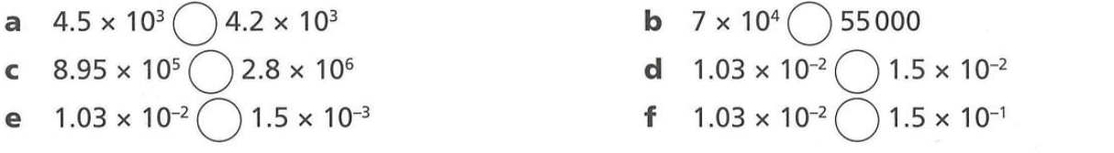
- Compare these numbers using <, >, or =

> >
< <
> <

- Arrange the following sets of numbers in ascending order.
$$6.3×{10}^{5}, 0.0056×{10}^{8}, 672 000,$$  0.0056 × 10⁸, 6.3 × 10⁵, 672,000 | $$0.000234, 2.341×{10}^{-3}, 234.01×{10}^{-5}$$  0.000234, 234.01 × 10⁻⁵, 2.341 × 10⁻³

- Write these numbers from largest to smallest.
$$2.41 × {10}^{6}, 24.2 × {10}^{5}, 0.239 × {10}^{7}, 2421 × {10}^{3}, 0.02 × {10}^{8}$$

$$2421×{10}^{3}, 24.2×{10}^{5}, 2.41×{10}^{6}, 0.239×{10}^{7}, 0.02×{10}^{8}$$
- Here are four number cards:

  - Which card is 10 times greater than A? ………………………………………………
B
  - Which card is 100 times smaller than D? ………………………………………………
C
  - E is a thousand times greater than A. Write E in scientific notation. ………………………
$$1.6×{10}^{7}$$

Development
- Choose the correct answer to each calculation,
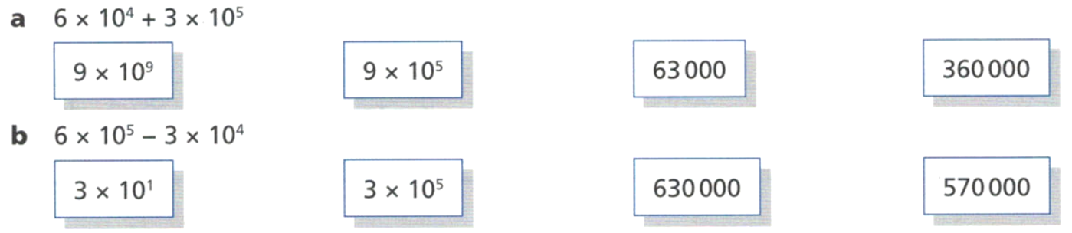

360 000

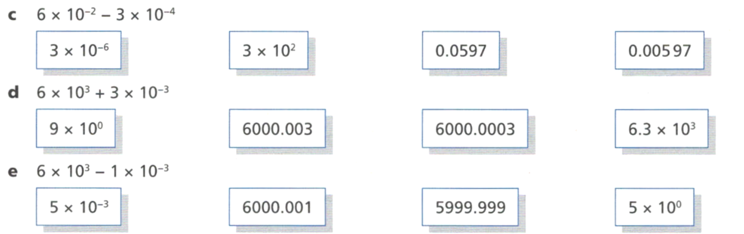
570 000

0.0597

6000.003

5999.999

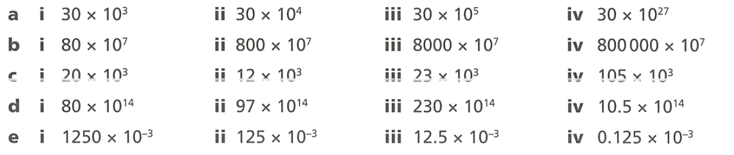
- Rewrite each number in scientific notation.
$$3×{10}^{4}$$ | $$3×{10}^{5}$$ | $$3×{10}^{6}$$ | $$3×{10}^{28}$$
$$8×{10}^{8}$$ | $$8×{10}^{9}$$ | $$8×{10}^{10}$$ | $$8×{10}^{12}$$
$$2×{10}^{4}$$ | $$1.2×{10}^{4}$$ | $$2.3×{10}^{4}$$ | $$1.05×{10}^{5}$$
$$8×{10}^{15}$$ | $$9.7×{10}^{15}$$ | $$2.3×{10}^{16}$$ | $$1.05×{10}^{15}$$
$$1.25$$ | $1.25×{10}^{-1}$ | $$1.25×{10}^{-2}$$ | $$1.25×{10}^{-4}$$

- Work out the missing numbers.
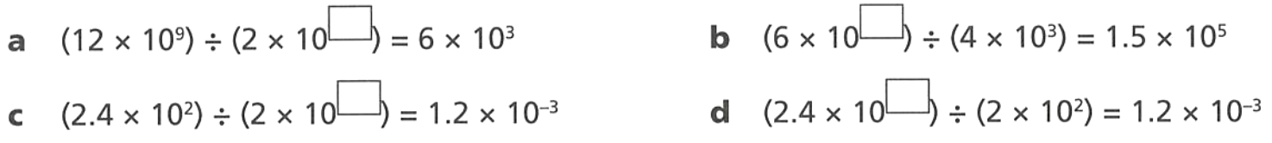  6 | 8
5 | $$-1$$

Mastery
- Using index laws, calculate the following and express your answer in scientific notation.
- $\left(2×{10}^{3}\right)×(3×{10}^{6})$  $$6×{10}^{9}$$ | - $\left(7×{10}^{-5}\right)×(4×{10}^{-2})$  $$2.8×{10}^{-2}$$
- $\frac{8×{10}^{5}}{2×{10}^{-2}}$  $$4×{10}^{7}$$ | - $\frac{7×{10}^{-7}}{7×{10}^{-3}}$  $$1×{10}^{-4}$$


- A bag of ants is 4 kg. Each ant is roughly 0.000 002 kg.
  - First, express 0.000 002 kg in scientific notation:
$$2×{10}^{-6}$$
  - Determine how many ants are in each bag.
You shouldn’t need a calculator if you know your index laws!
$$\frac{4}{2×{10}^{-6}}=2×{10}^{6}$$
  - If an average ant weighs 2 mg and there are around 20 quadrillion $(20×{10}^{15})$ ants in the world, how much do all the ants in the world weigh?
$$\left(20×{10}^{15}\right)×\left(2×{10}^{-6}\right)=40×{10}^{9}=4×{10}^{10} kg$$
  - If an average human weighs 60 kg and there are 8 billion $\left(8×{10}^{9}\right)$ humans, how much do all the humans in the world weigh?
$$60×\left(8×{10}^{9}\right)=480×{10}^{9}=4.8×{10}^{11} kg$$
  - Do all the ants in the world weigh more or all the humans?
humans
- An average adult has about 20 000 000 000 000 red blood cells.
Each red blood cell has a mass of about 0.000 000 000 1 gram.
Work out the total mass of the red blood cells in an average adult.
Give your answer in scientific notation.

$$\left(2×{10}^{13}\right)×\left(1×{10}^{-10}\right)=2×{10}^{3} g$$
- The speed of light is $3×{10}^{8}$ m/s. The distance to the sun is $1.5×{10}^{11}$ m.
Calculate the time, in minutes, it takes for light to travel from the sun to Earth.

$$\left(1.5×{10}^{11}\right)÷\left(3×{10}^{8}\right)=8.330 mins$$
Use a calculator for the following questions.
- If $y=0.5x^{2},$ calculate the value of $y$ in scientific notation when $x=9.8×{10}^{-3}$

$$4.02×{10}^{-5}$$
- Given that $V=\frac{r}{\sqrt{h}},$ find the value of $r$ in scientific notation when $V=5×{10}^{4}$ and $h=9×{10}^{6}$

$$1.5×{10}^{8}$$
- Find $x$ in scientific notation, given that $x^{3}=8×{10}^{12}$

$$2×{10}^{4}$$
- Use the formula $E=mc^{2}$ to find $c$ in scientific notation, given that
$E=4.05×{10}^{18}$ and $m=45$.

$$3×{10}^{8}$$
- 2009 HSC Standard 2 Band 6
The mass of a sample of microbes is 50 mg.
There are approximately $2.5×{10}^{6}$ microbes in the sample.
In scientific notation, what is the approximate mass in grams of one microbe?

$$0.05 g÷\left(2.5×{10}^{6}\right)$$
$$2×{10}^{-8} g$$
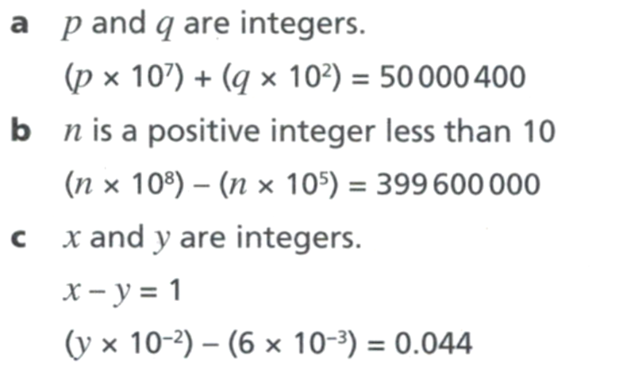
- Find the value of each letter,

$$p=5, q=4$$

$$n=4$$

$$y=5, x=6$$

Scientific Notation and Significant Figures

- Scientific Notation and Significant Figures
- For a number written in scientific notation $a×{10}^{n}$, every digit of $a$ is significant.
  - $1.02×{10}^{5}$ has 3 significant digits.
  - $6.0×{10}^{-3}$ has 2 significant digits.
- Rounding to a significant figure and scientific notation:
- Write the number in scientific notation $a×{10}^{n}$
- Round $a$ to the required significant figure.

- Example Write numbers in scientific notation and round to a significant figure
Write these numbers using scientific notation to three significant figures.
2 183 000  1. $2.183 000$  $2.183×{10}^{6}$  2. $2.18×{10}^{6}$ | 0.001 948 2  1. $0 001.9482$  $1.9482×{10}^{-3}$  2. $1.95×{10}^{-3}$

- Guided Practice
Write these numbers using scientific notation to three significant figures.
- 487 830  1.  2.  $4.88×{10}^{5}$ | - 0.06531  1.  2.  $$6.53×{10}^{-2}$$

Foundation
- State the number of significant figures given in these numbers.
- $0.272$  3 | - $1007$  4 | - $0.20$  2 | - $1.3$  2
- $1.3×{10}^{3}$  2 | - $4.21×{10}^{3}$  3 | - $2.905×{10}^{-2}$  4 | - $1.700×{10}^{-6}$  4

- Write these numbers using scientific notation and three significant figures.
- 242 300  2.42 × 10⁵ | - 2 829  2.83 × 10³ | - 0.000 342 76  3.43 × 10⁻⁴
- 0.006 859  6.86 × 10⁻³ | - 0.172 046  1.72 × 10⁻¹ | - 326.042  3.26 × 10²

- Write using scientific notation rounding to the number of significant figures in brackets.
- 47 760 (3)  4.78 × 10⁴ | - 4 833 160 (4)  4.833 × 10⁶ | - 929.502 (1)  9 × 10²
- 0.002 81 (2)  2.8 × 10⁻³ | - 0.000 101 (1)  1 × 10⁻⁴ | - 37.66 (2)  3.8 × 10¹

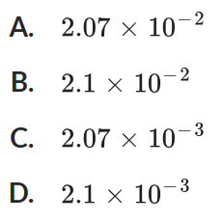
- 2020 HSC Standard 2 Band 5
What is 0.002073 expressed in scientific notation with two significant figures?

D
- 2019 HSC Advanced Band 3
What is the value of $π^{10}$ to two significant figures.
    - $9.36×{10}^{4}$
    - $9.4×{10}^{4}$
    - $9.36×{10}^{5}$
    - $9.4×{10}^{5}$
B

Development
- Cheryl was asked to write 80 000 in scientific notation to 2 s.f.
She wrote $8×{10}^{5}$.
  - Explain why this is incorrect.
This is only 1 significant figure
  - What should she have written?
$$8.0×{10}^{5}$$
- Round the following to 3 s.f.
- $2.302×{10}^{2}$  $$2.30×{10}^{2}$$ | - $4.897×{10}^{-4}$  $$4.90×{10}^{-4}$$ | - $3.996×{10}^{6}$  $$4.00×{10}^{6}$$

- Calculate, give answer in scientific notation and round to four s.f.
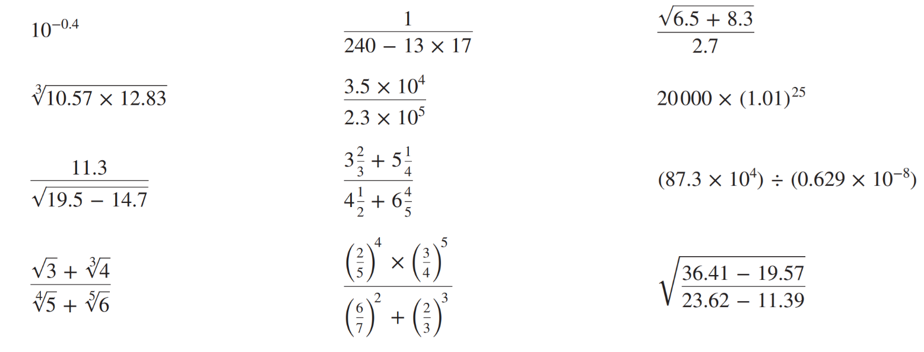  $3.981×{10}^{-1}$ | $$5.263×{10}^{-2}$$ | $$2.565×{10}^{4}$$
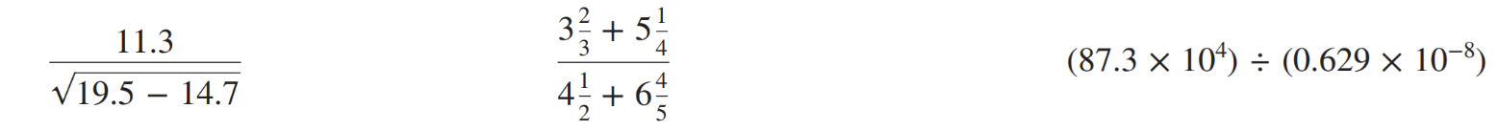  5.158 | $$7.891×{10}^{-1}$$ | $$1.388×{10}^{14}$$

- The mass of a proton is $1.6726×{10}^{-27}$ kg and the mass of an electron is $9.1095×{10}^{-31}$ kg.
  - Calculate, correct to 4 s.f., the ratio of the mass of the proton to the mass of an electron (i.e. how many times as heavy is a proton compared to an electron?)

1836 times as heavy
  - How many protons are there in 1 kg? Answer in scientific notation to 4 s.f.

$$5.979×{10}^{26}$$

